

# AMERICAN INTERNATIONAL UNIVERSITY-BANGLADESH (AIUB)

Faculty of Engineering

Bachelor of Science in Electrical and Electronic Engineering (EEE) BAE 2101: Computer Aided Design and Drafting

**Experiment # 06:** Understanding and drawing Civil Plan using AutoCAD software**.**

**Objective:** To familiarize students with proper understanding of drawing of Civil Plan and draw this plan using AutoCAD software.

# Sample Drawing:

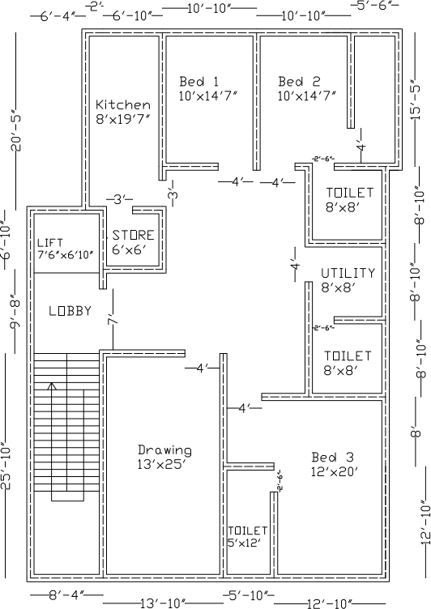

**Discussion and Conclusion:**

Interpret the findings and determine the extent to which the experiment was successful in complying with the goal that was initially set. Discuss any mistake you might have made while conducting the designing and describe ways the study could have been improved.

# References:

1. Kristen S. Kurland, “AutoCAD 2004, 2D Training Manual”.
2. Bob McFarlane, “Beginning AutoCAD 2004”.
3. David Byrnes and Mark Middlebrook, “AutoCAD 2007 For Dummies”.